Here is a GREAT way to honor your JCHS student athlete! The Carson Booster Club is proud to offer a Personalized Sign (PAW) with your student athlete’s name, sport and number in the appropriate JCHS athletic areas!
- $30/each
- 1-sided
- Personalized (name can be up to 20 characters long)
- Lightweight & weather-resistant
- 23 in. x 22 in.
- Metal stake included

The signs will be mounted inside on the walls of the school/gym, or they can also be mounted onto a fence during particular sports seasons. After the season is over, you may have the personalized sign for a keepsake.
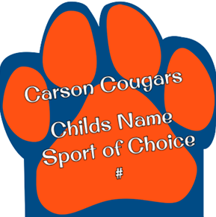

All orders must be placed by August 9, 2019.

Return this form to your coach with your $30 payment.

If you have any questions please contact Stacey Burleyson at 704-239-0700
or email the Booster Club at boostersjchs@gmail.com.

Parent(s) Name ________________________________________________________________
Phone # ______________________________________________________________________
Email ________________________________________________________________________
Student Athlete Name___________________________________________________________
2019-2020 Grade Level _______
Sport ________________________________________________________________________
Jersey #_____________ (If not known, we will verify with the coach)
Booster Club Use Only:
DATE PAID _________________ CASH __________ CHECK # __________

