Senior Banner
Order Form

Orders are due by August 9, 2019

Return this form to your coach with your $50 payment.
Make checks payable to: Carson Booster Club

Athlete’s name to appear on banner:
_______________________________________
Sport:
_______________________________________

Parent Information
Name:
Phone:
Email:
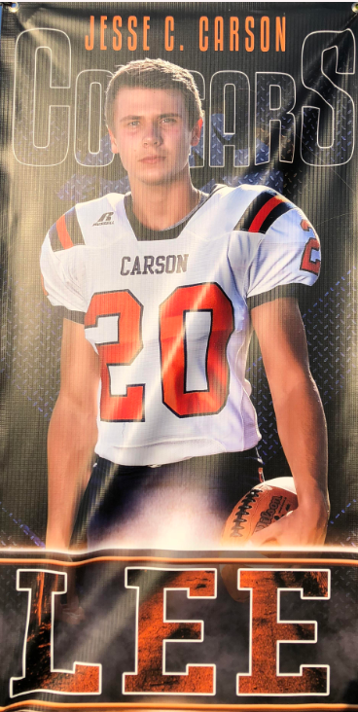
Booster Club Use Only:
DATE PAID ___________________
CASH __________ CHECK # __________
Please note that all banners will be placed in the area that the sport is being played for that season only. Once the banners are hung, it will be the responsibility of the parent(s) to remove the banner for keepsake purposes. Once the banner is hung up, it is no longer the responsibility of the Carson Booster Club.

